**Web Programming**

Lab - 3

HTML – Image Mapping

Name: Sushen Grover

Reg No: 23BCE1728

Slot: L11+L12+L31+L32

Class No: CH2024250502774

Course Code: BCSE203E

Faculty: Dr. L.M. Jenila Livingston

Question 1:

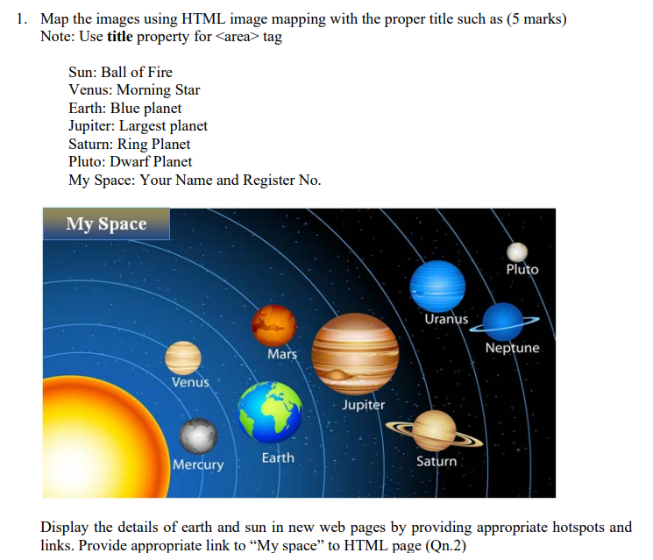

Code:

<!DOCTYPE html>

<html lang="en">

<head>

    <meta charset="UTF-8">

    <meta name="viewport" content="width=device-width, initial-scale=1.0">

    <title>23BCE1728</title>

</head>

<body>

    <h1>Exercise 3A</h1>

    <p>Click on the planet to veiw its information</p>

    <img src="img.png" usemap="#image-map">

    <map name="image-map">

        <area target="_blank" alt="My Space" title="My Space" href="myspace.html" coords="1,1,176,100" shape="rect">

        <area target="_blank" alt="Earth" title="Earth" href="https://science.nasa.gov/earth/" coords="418,147,36" shape="circle">

        <area target="_blank" alt="Mars" title="Mars" href="https://science.nasa.gov/mars/" coords="616,262,36" shape="circle">

        <area target="_blank" alt="Venus" title="Venus" href="https://science.nasa.gov/venus/" coords="228,188,32" shape="circle">

        <area target="_blank" alt="Mercury" title="Mercury" href="https://science.nasa.gov/mercury/" coords="154,340,22" shape="circle">

        <area target="_blank" alt="Saturn" title="Saturn" href="https://science.nasa.gov/saturn/" coords="155,502,54" shape="circle">

        <area target="_blank" alt="Uranus" title="Uranus" href="https://science.nasa.gov/uranus/" coords="312,629,50" shape="circle">

        <area target="_blank" alt="Neptune" title="Neptune" href="https://science.nasa.gov/neptune/" coords="499,623,47" shape="circle">

        <area target="_blank" alt="jupiter" title="jupiter" href="https://science.nasa.gov/jupiter/" coords="648,457,77" shape="circle">

        <area target="_blank" alt="sun" title="sun" href="https://science.nasa.gov/sun/" coords="397,394,125" shape="circle">

    </map>

</body>

</html>

Output:

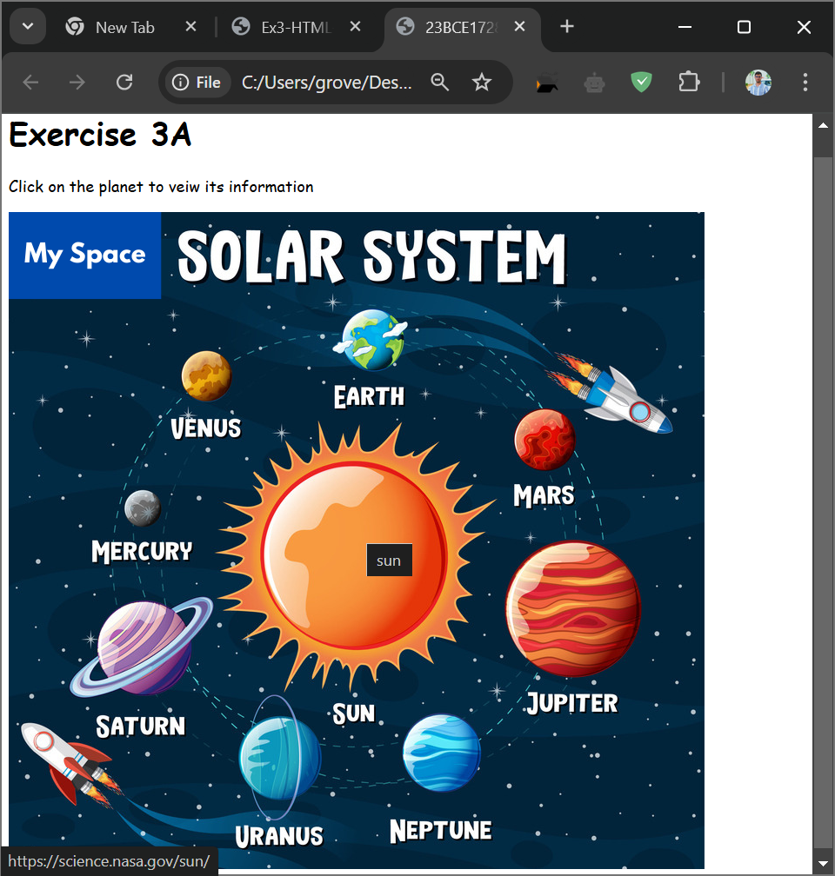

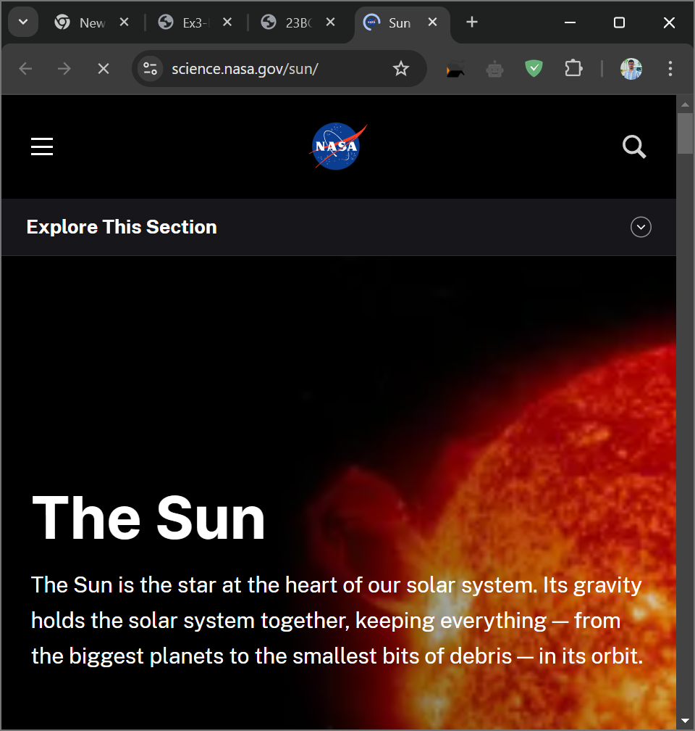

Question 2:

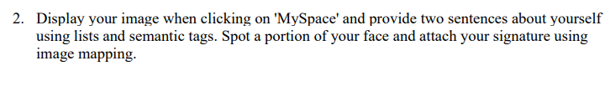

Code:

<!DOCTYPE html>

<html lang="en">

<head>

    <meta charset="UTF-8">

    <meta name="viewport" content="width=device-width, initial-scale=1.0">

    <title>23BCE1728</title>

</head>

<body>

    <img src="pp.jpg" usemap="#image-map" alt="Profile Photo"  *align*="right">

    <map name="image-map">

        <area target="_blank" alt="face" title="face" href="https://www.linkedin.com/in/sushen-grover-2b3314290/" coords="178,162,110" shape="circle">

    </map>

    <h1>Exercise 3B</h1>

    <h2>Sushen Grover</h2>

    <h3>About Me</h3>

    <p>

        I am a Computer Science and Engineering student at VIT Chennai with a passion for problem-solving and creating efficient, impactful solutions. I have a strong foundation in Data Structures and Algorithms and am skilled in programming languages like Python, Java, C, and C++. I also have experience in data analytics, using tools such as MySQL, Spreadsheets, Tableau, and R to uncover meaningful insights and support data-driven decision-making.

    </p>

    <p>

        I take on challenges with a calm, focused mindset and always prioritize sincerity and precision in my work. With a forward-thinking approach, I adapt quickly to demanding situations and consistently aim to achieve excellence in everything I do.

    </p>

</body>

</html>

Output:

